Exercise #1

For each department in AdventureWorks, show the number of employees currently working in that department. The results should look like this. You should verify that the total adds up to 290 employees (you can do a count on the Employees table to verify this). This should be sorted by department name, and the headers should be as displayed below:

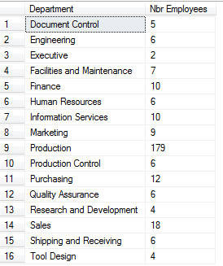

Exercise #2

List all the employees and the department to which they currently belong. Sort it by department, then within department by last name followed by first name. Again, you should see 290 employees:

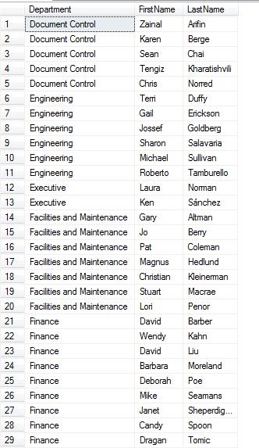

Exercise #3

List all the employees and the department to which they currently belong, along with their current pay rate and the date of their last raise. Sort it by department, then within department by last name followed by first name. Again, you should see 290 employees. The display should look like this:

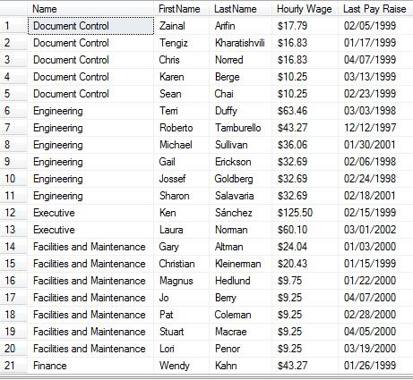

Hint: for getting a correct date format, check out the CONVERT function in the SQL Server documentation.

HINT: to get the last pay raise for the employee, you need to do a correlated subquery.

Exercise #4

List the employees who have transferred between departments during their employment. You should show their current department, and the date when the transferred to the current department. This is a pretty tough query. My solution was to use a subquery to determine which employees have been in more than one department, and use that result in the base query. The results should look like this:

